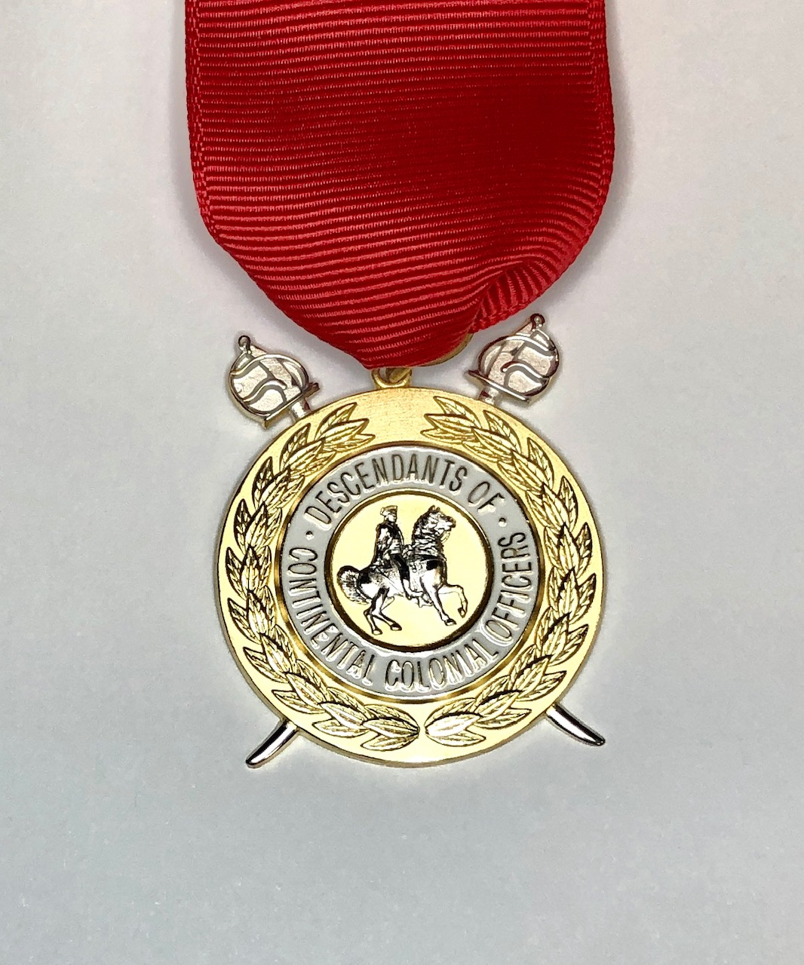
Descendents of Continental Colonial Officers Insignia Order Form
Member Number _____
Buyer's Name: __________________________________________ Phone: _______________
Address: ______________________________________ E-Mail: ______________________
City: ___________________________________ State: _______ Zip :________________
Insignia Prices to Members
All insignia are supplied with a ribbon drape and box. All items are available in 10K or 14K gold. Prices available upon request.
QTY. DESCRIPTION PRICE TOTAL _____ Large Insignia, Gold Electroplate over Base Metal _______
_____ Large Insignia, 1/20 10K Gold-Filled _______
_____ Gentleman's Neck ribbon (officers) (spring ring) _______
_____ Lady's Bow and Tails (fringed) (officers) _______
_____ Miniature Insignia, Gold Electroplate over Base Metal _______
_____ Miniature Insignia, 1/20 10K Gold-Filled _______
ENGRAVING: Number of Characters _____ @ $.35 per character
________________________ block print characters to be engraved on back of the insignia ________
Pennsylvania residents please add 6% sales tax: ________
Please add ..... per package for shipping UPS ground ________
GRAND TOTAL ________
Please order directly from Citypride, LTD. at 1-888-679-8888 or online at www.cityprideltd.com. This form is for your information and not necessary to send to Citypride to complete your order. They will ship and bill you directly.

